BIT 4107-Mobile Application Development
ENHANCED PROFESSIONAL STUDENT LOGBOOK
Student name: ANN ITOTIAH
Admission Number: BIT/2024/ 54209
School/Faculty: COMPUTING AND INFORMATICS
Programme :
Academic Year: THREE
Semester: TWO
Lecturer: MICHAEL NYORO
Phone Number:0718822722

WEEK 1: INTRODUCTION TO MOBILE APPLICATION DEVELOPMENT
TOOLS AND SOFTWARE USED
Android Studio
VS Code
Flutter SDK
Dart
Android Phone

PERSONAL REFLECTION
During my project development, I used VS Code, Android Studio, Flutter SDK, Dart, and an Android phone to build and test my application.
VS Code was my main coding tool because it is fast, simple, and supports Flutter development well.
Android Studio was mainly used for the emulator and debugging, which helped me test the app on virtual devices.
The Flutter SDK allowed me to build a cross-platform mobile app using a single codebase, while Dart was the programming language used to write the app’s logic and structure.
Finally, I used an Android phone for real testing, which helped me see how the app performs in real-life conditions.
Overall, these tools worked well together and helped me successfully develop and test my project while improving my mobile app development skills.
WEEK 2: MOBILE DEVELOPMENT ENVIRONMENT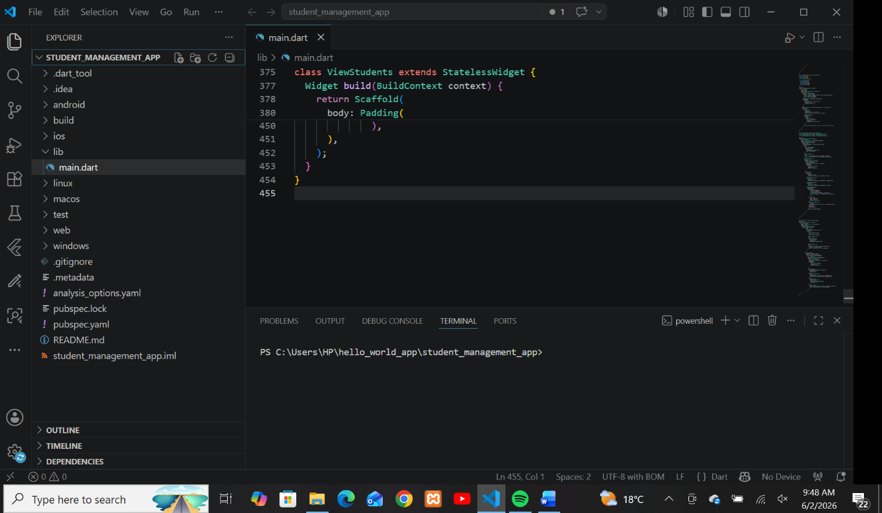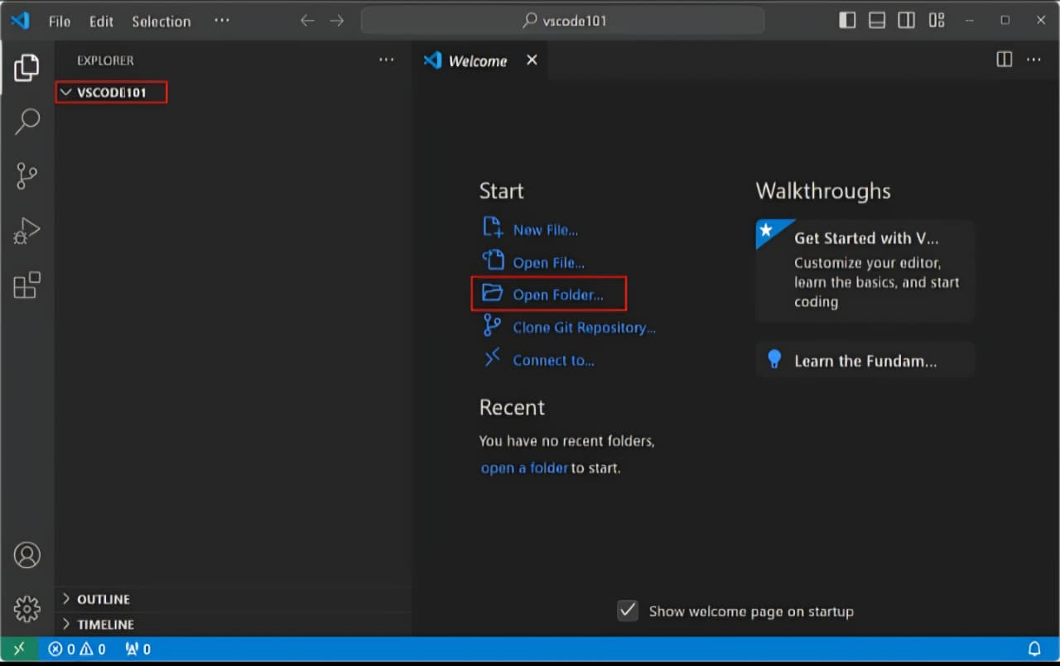

PERSONAL REFLECTION
Developing a mobile application was a valuable learning experience that helped me understand how real-world apps are built. I used tools such as **VS Code, Android Studio, Flutter SDK, and Dart, along with an Android phone for testing. Through this project, I learned how to design user interfaces, write functional code, and connect different parts of an application together. Flutter made it easier to build a cross-platform app using one codebase, while Dart helped me structure the logic clearly.
I also learned the importance of testing, especially on a real device, because it helped me identify issues that were not visible in the emulator. Overall, this project improved my technical skills, problem-solving ability, and understanding of mobile app development from design to deployment.

WEEK 3: USER INTERFACE DESIGN

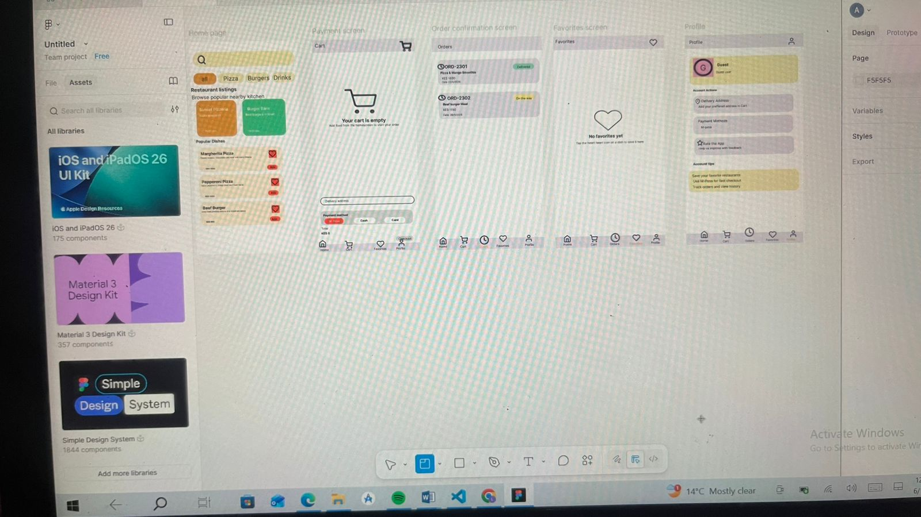

Personal reflection
I focused on user interface design for the Food delivery app using Figma. I learned how to create and organize screens, design user-friendly layouts, and improve overall system usability. This improved my understanding of UI/UX principles and enhanced my design skills.
Week 4: Event handling and user interaction
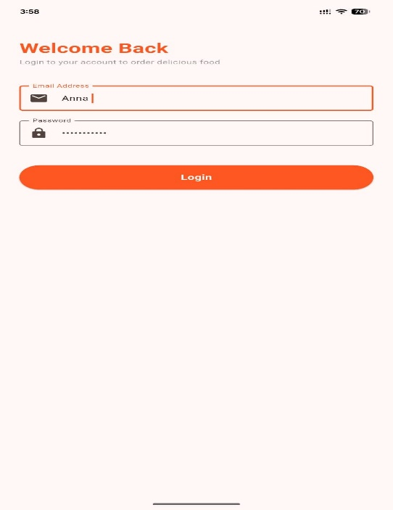
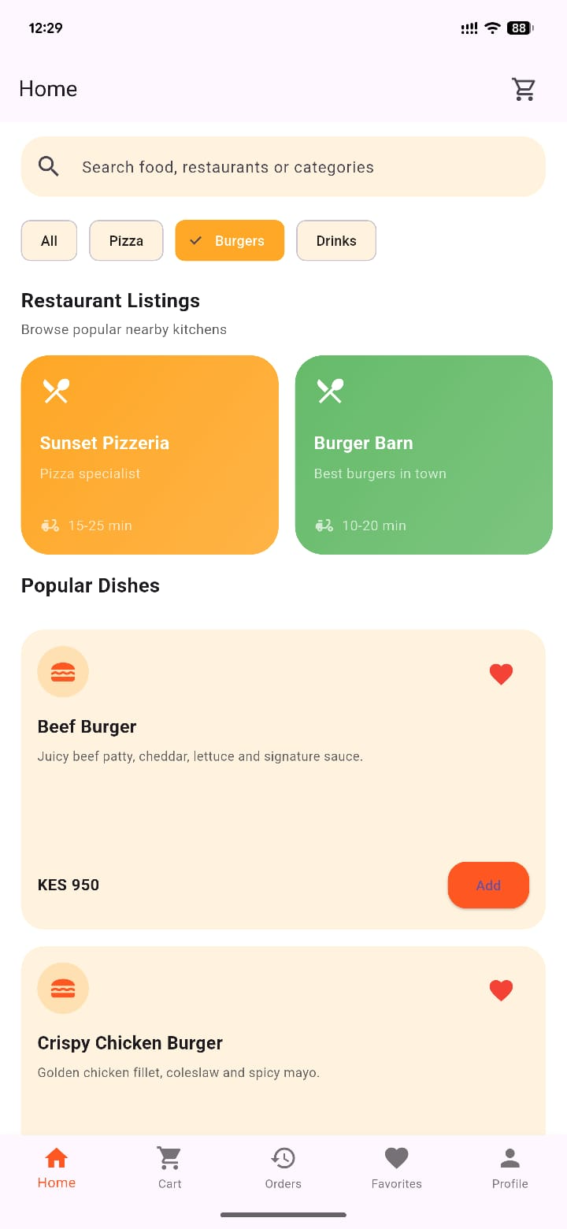
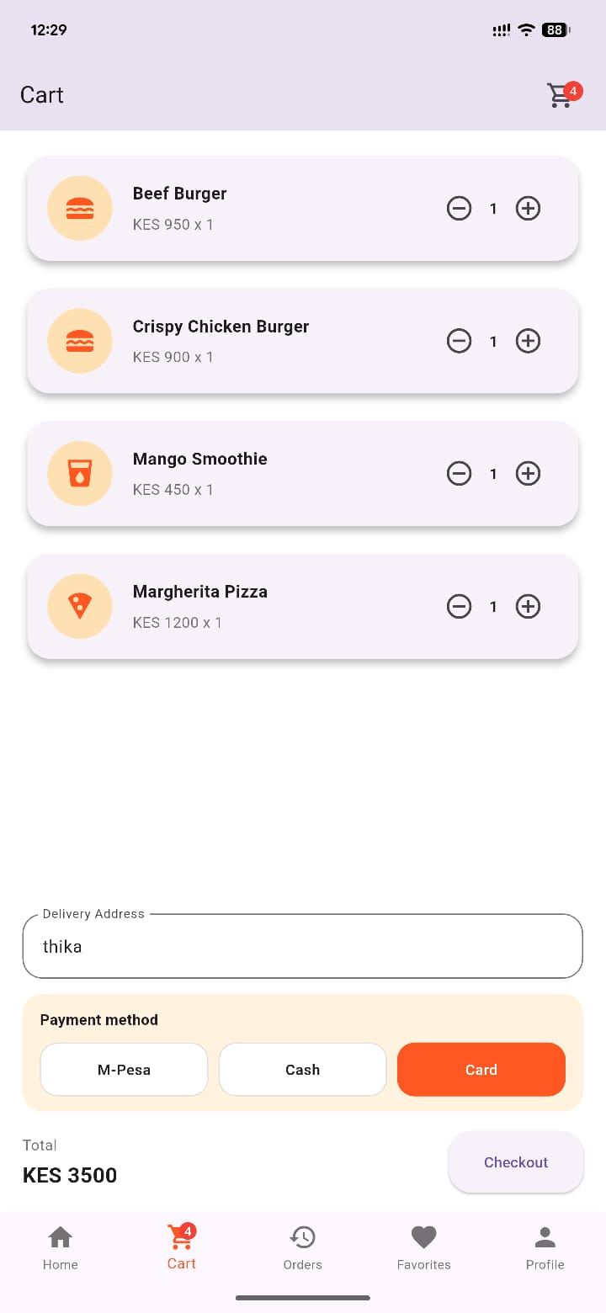

Personal reflection
I learned about event handling and user interaction in the food delivery app . I implemented how users interact with the system through buttons, forms, and input fields. This improved my understanding of how applications respond to user actions and enhanced my programming skills.
Week 5: Data management
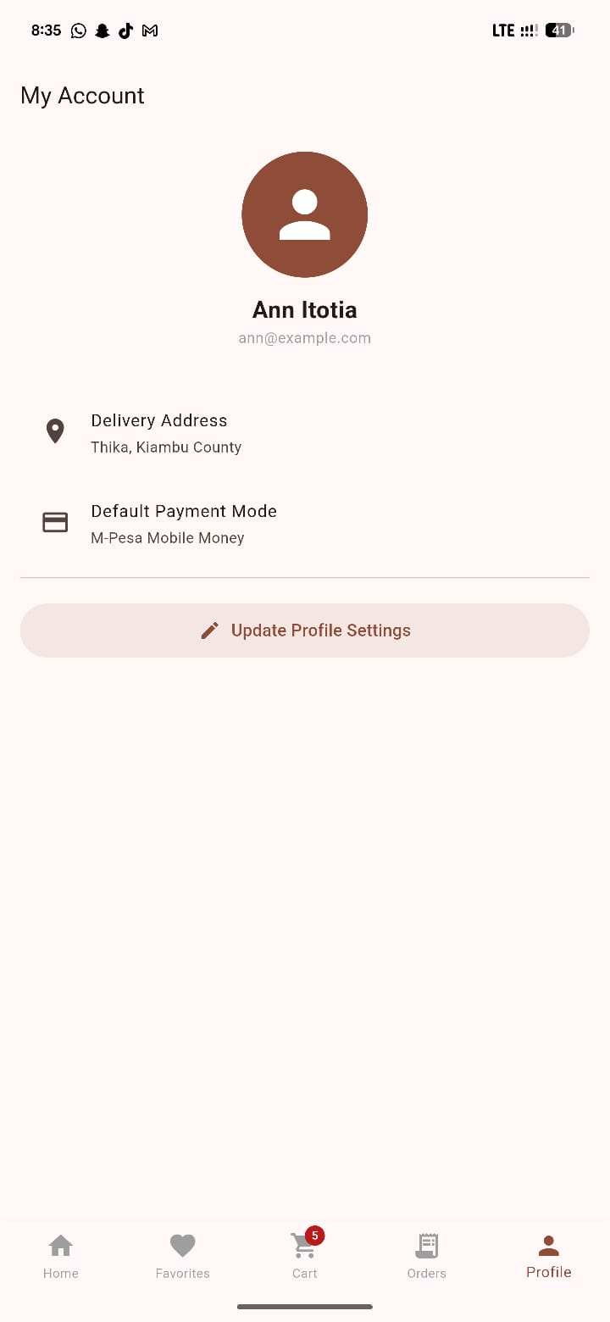
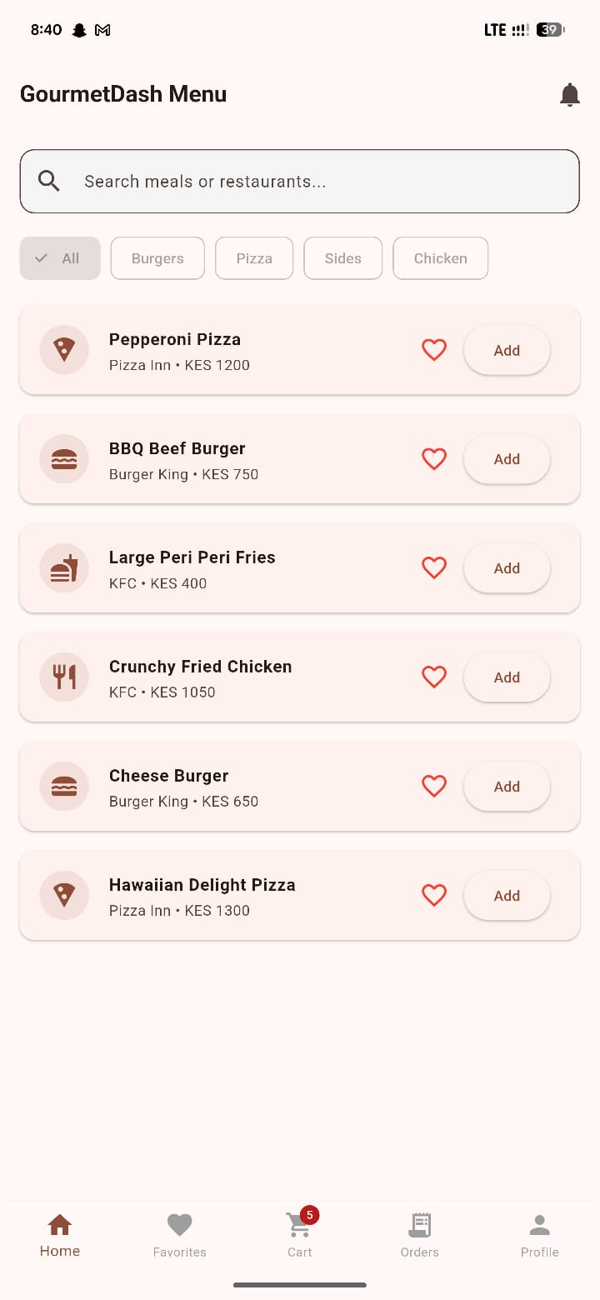

Personal reflection
I focused on data management in the food delivery App. I learned how to store, retrieve, update and request information using local storage and databases. The app helps me interact with the customer and even know their personal favorites meal. This improved my understanding of how data is handled efficiently and enhanced my skills in managing application data.
Week 6: NETWORKING AND API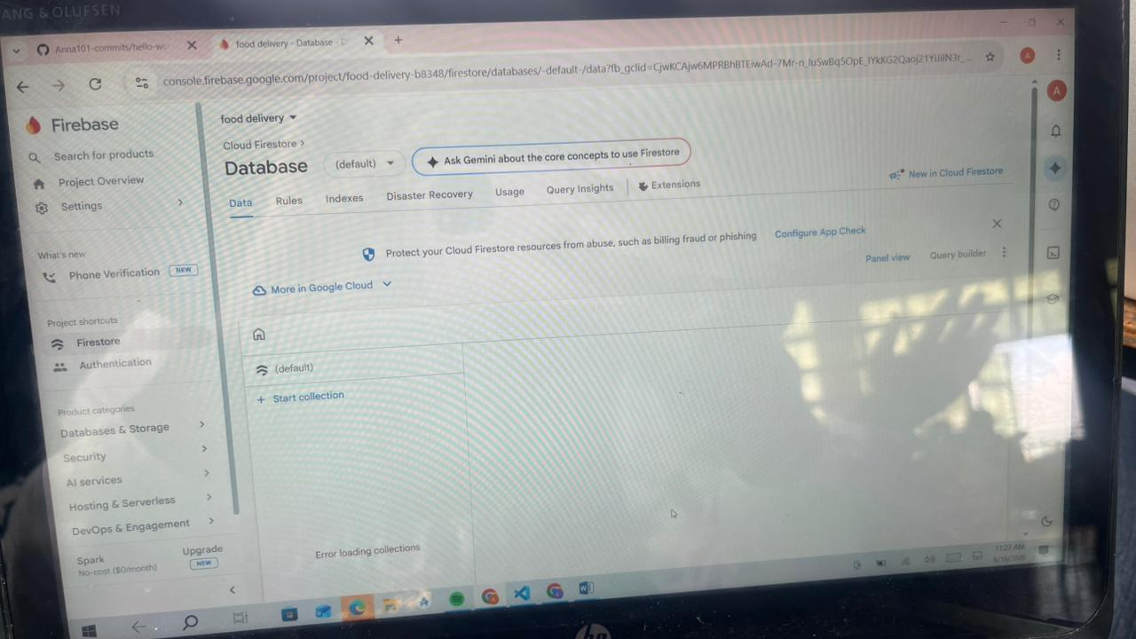
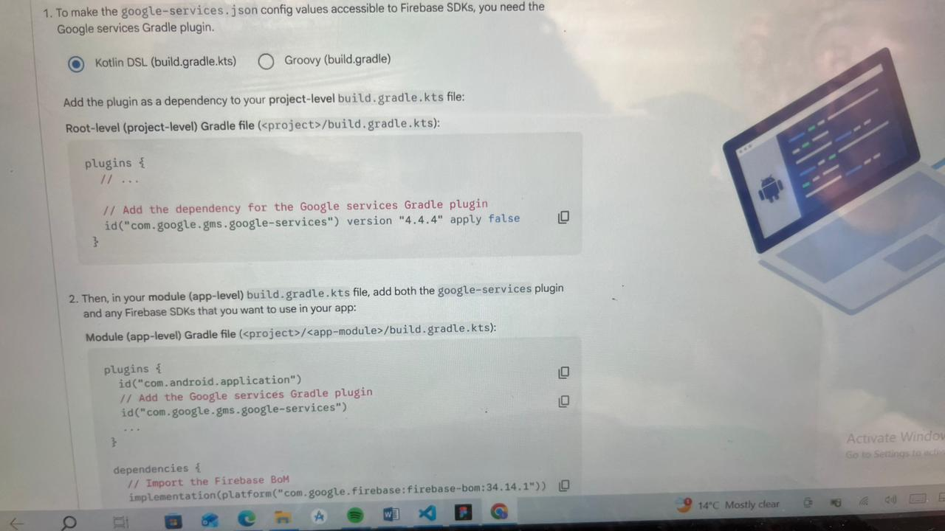
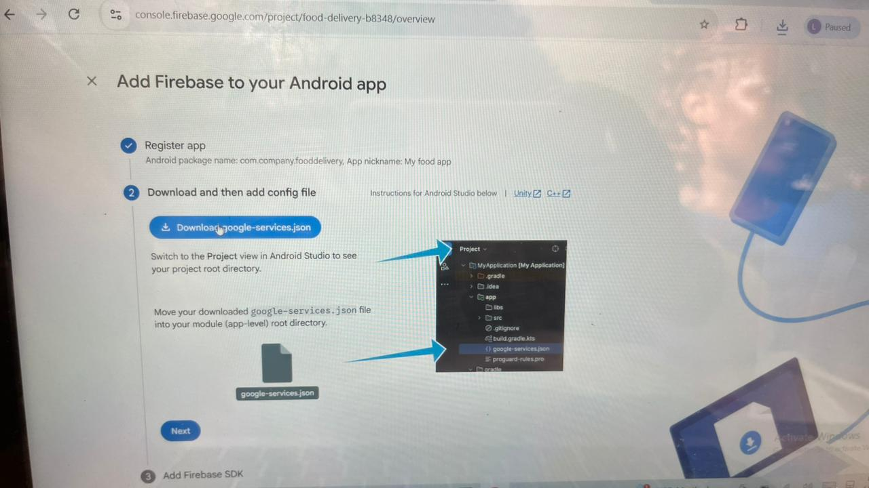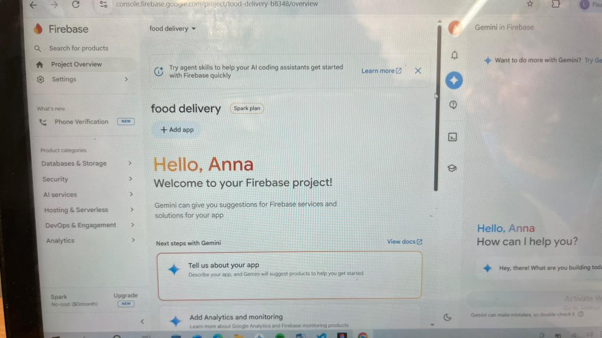
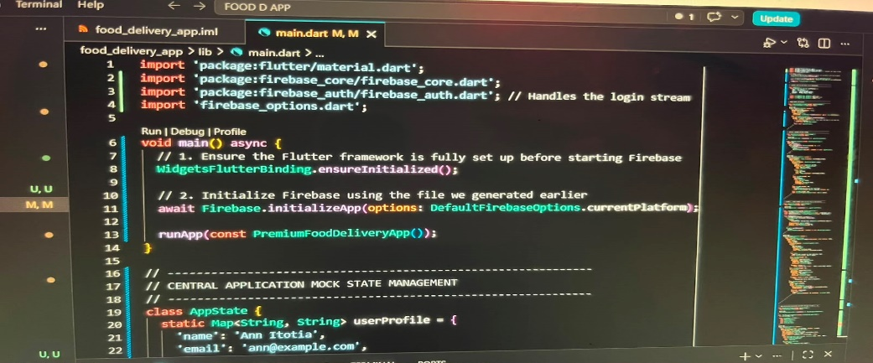

Why it requires networking
Networking enables login, data synchronization , workout updates and communication between the app and server
Personal reflection
Working with networking and API’S in the food delivery app helped me understand how applications communicate with external services to exchange data. I learned how API’S can be used to retrieve and update information. This experience also taught me the importance of error handling, data security and maintenance of a stable internet connectivity to ensure smoother running of my app. Working with Networking and API’S enhanced my technical skills.
Week 7;Data storage and intergration in mobile applications
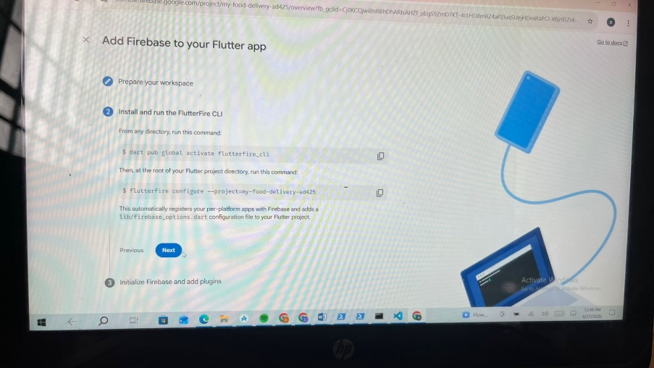

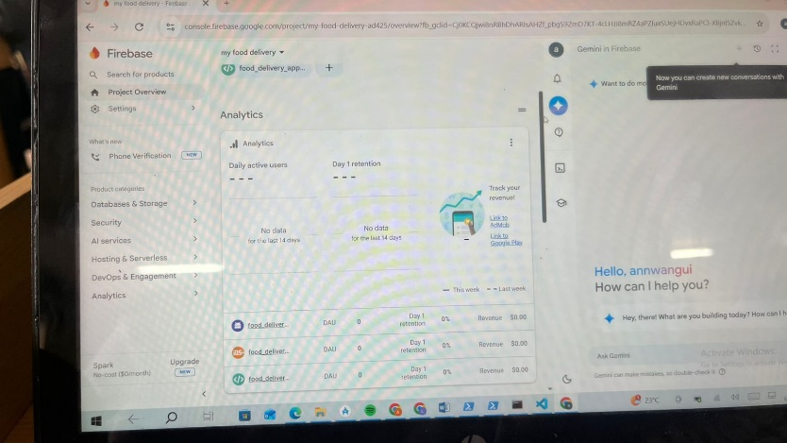
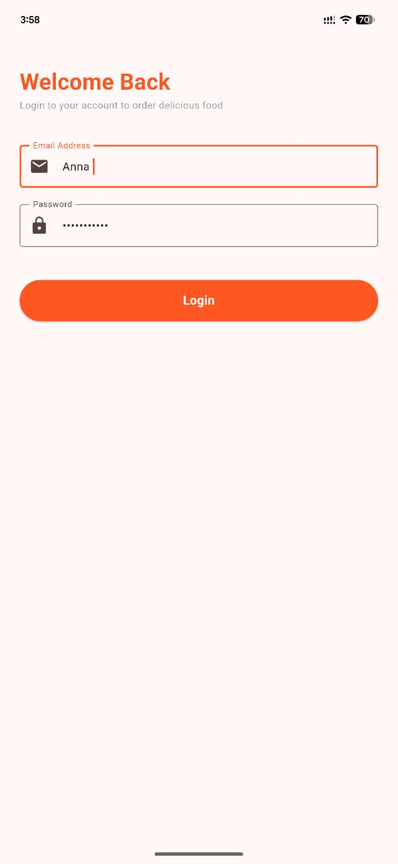
WEEK 8: HANDLING INPUTS AND EVENTS


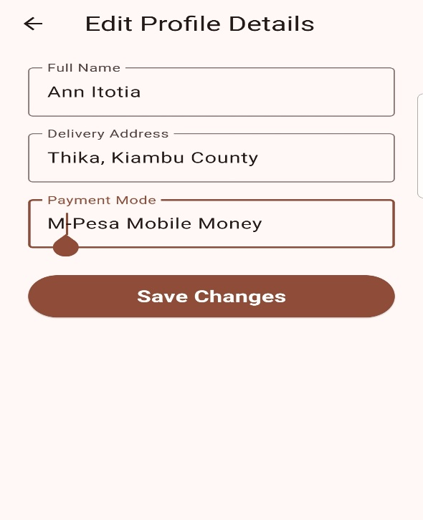
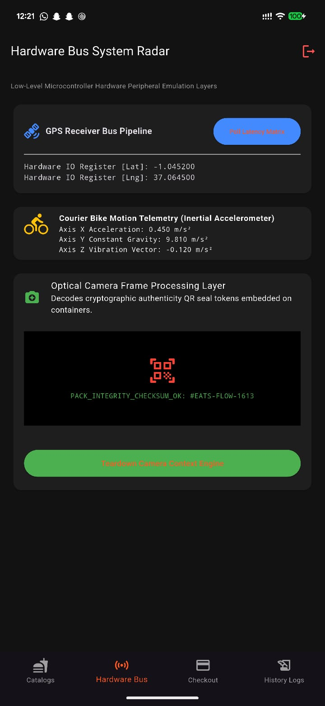
WEEK 9:DEVICE FEATURES INTERGRATION(CAMERA,GPS,SENSORS)
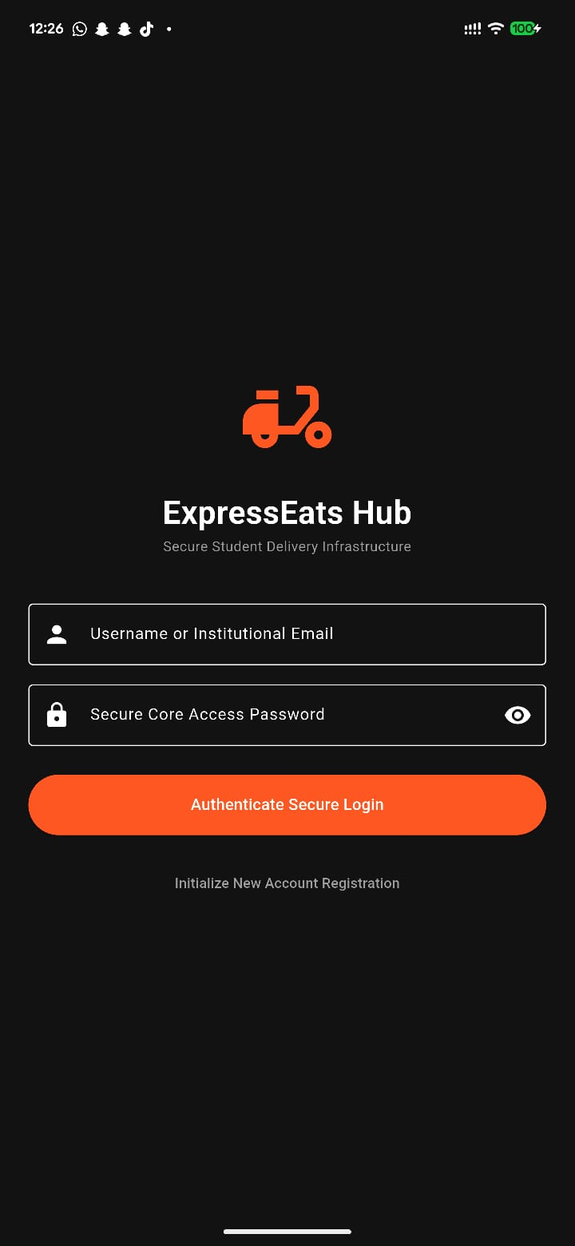
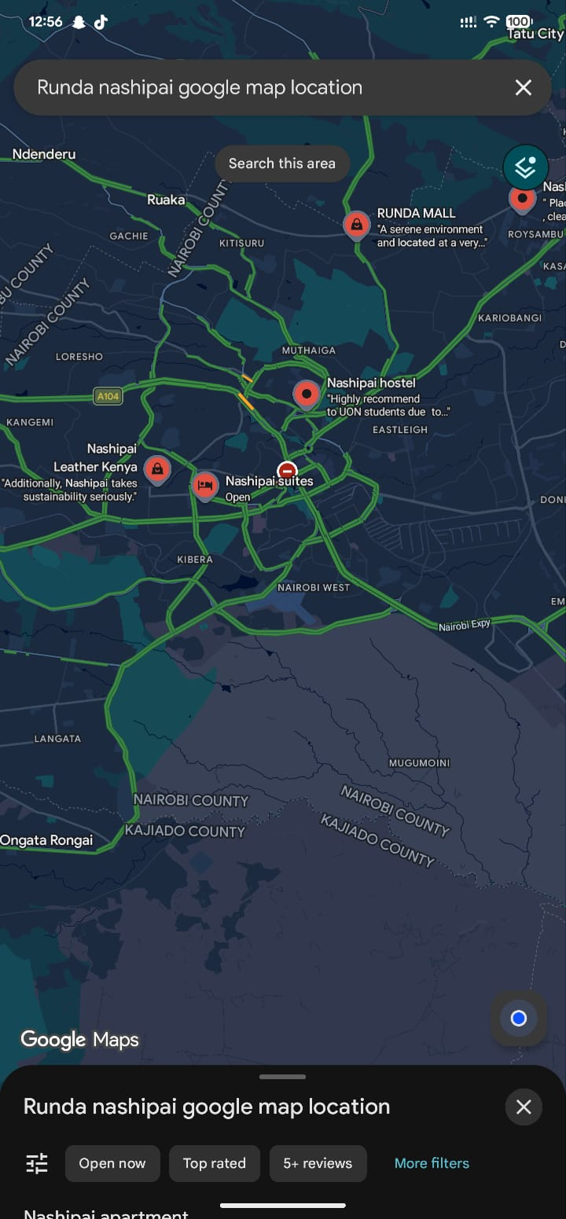
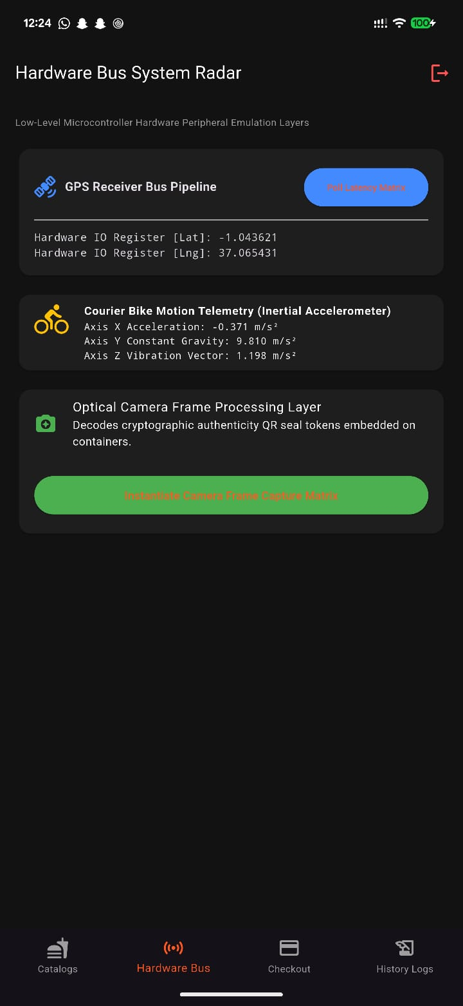

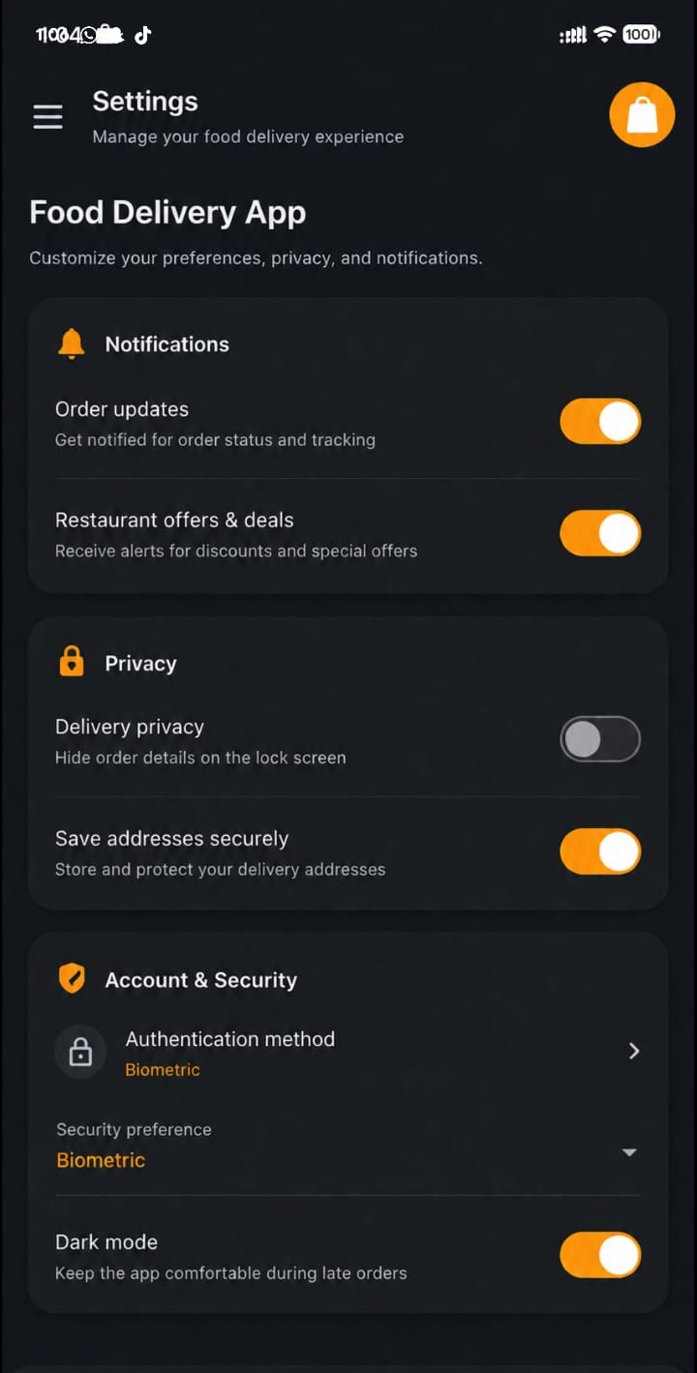
Personal reflection
Integrating device features like GPS, sensors, and the camera helped me understand how mobile hardware enhances a fitness app. I learned how these features improve activity tracking of orders and user engagement while creating a more interactive experience with the app.
WEEK 10: COMPREHENSIVE APPLICATION DEVELOPMENT INTERGRATION AND TESTING
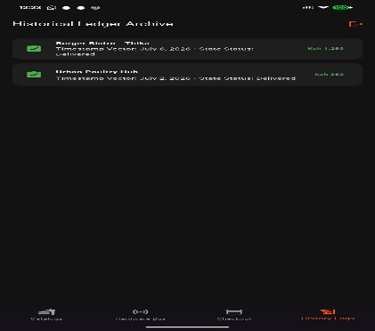
APP LOGO BEFORE
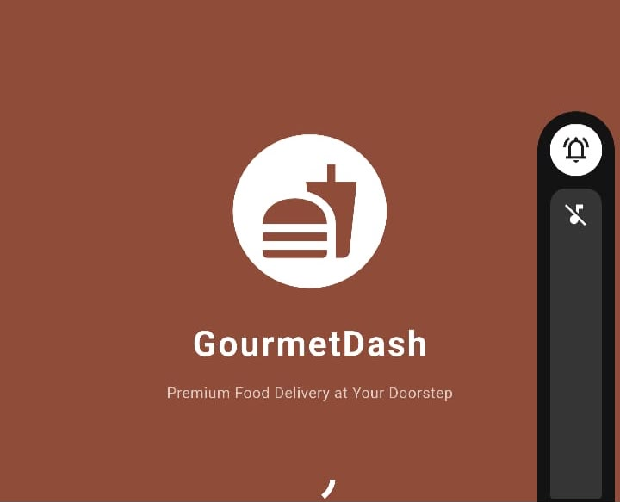
APP LOGO AFTER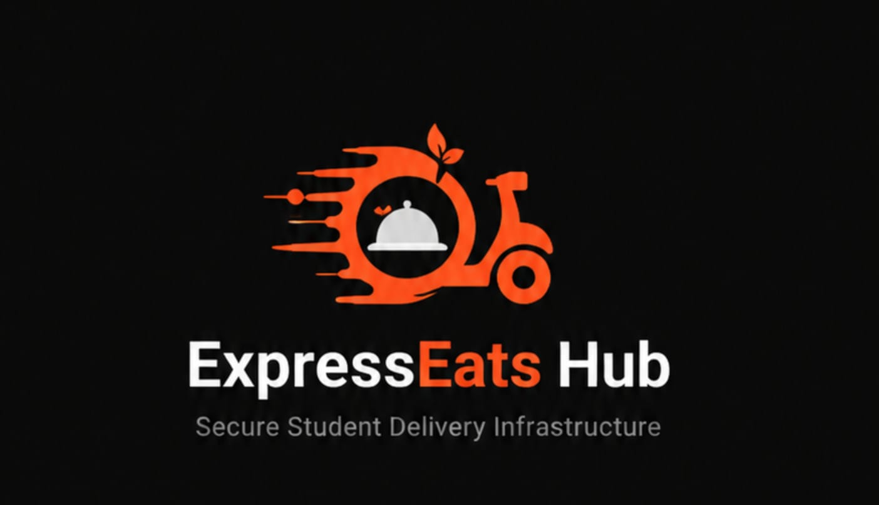
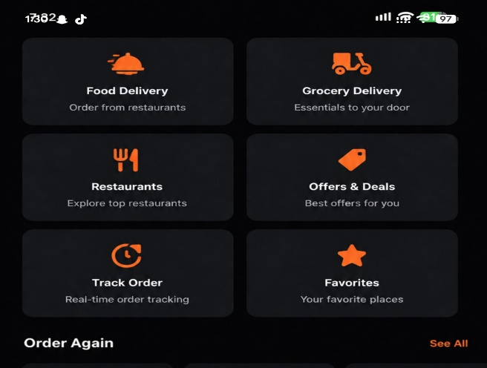
PERSONAL REFLECTION
Developing and integrating the food delivery app helped me understand how components like user authentication, menu browsing, order tracking, and food recommendations work together. Testing allowed me to identify bugs, optimize performance, and ensure every feature functioned smoothly. This experience sharpened my problem-solving and software testing skills while reinforcing the importance of building a reliable, user-friendly application.
WEEK 11: APPLICATION DEPLOYMENT AND PUBLISHING

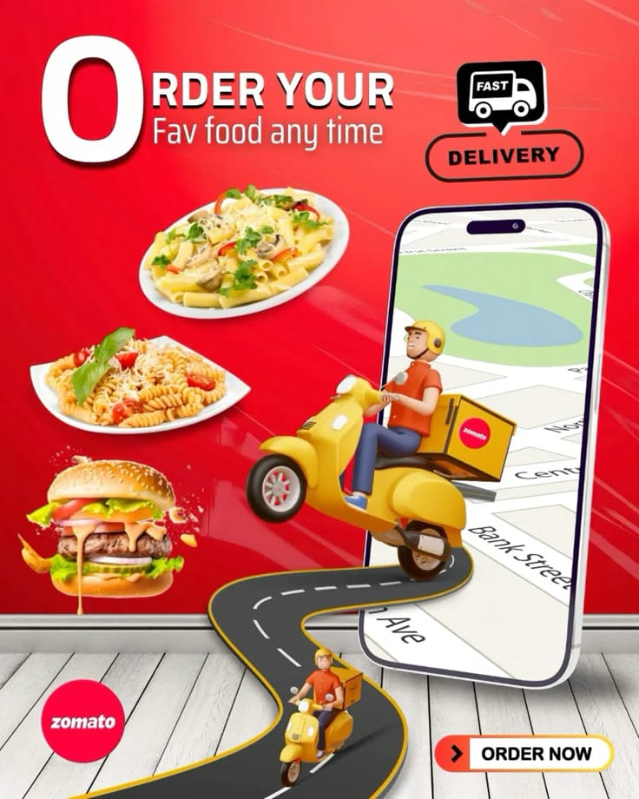
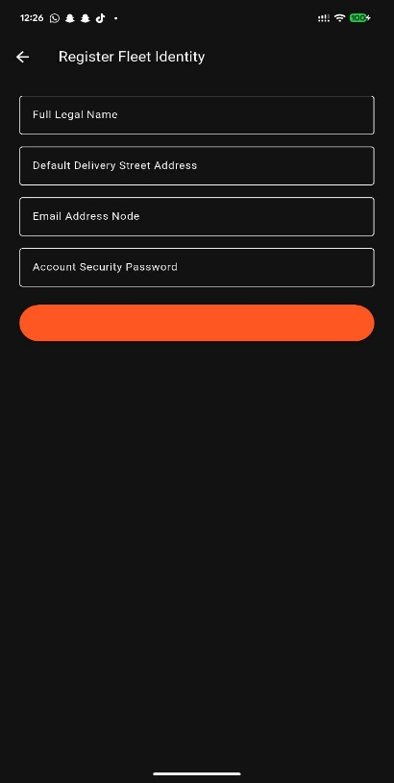
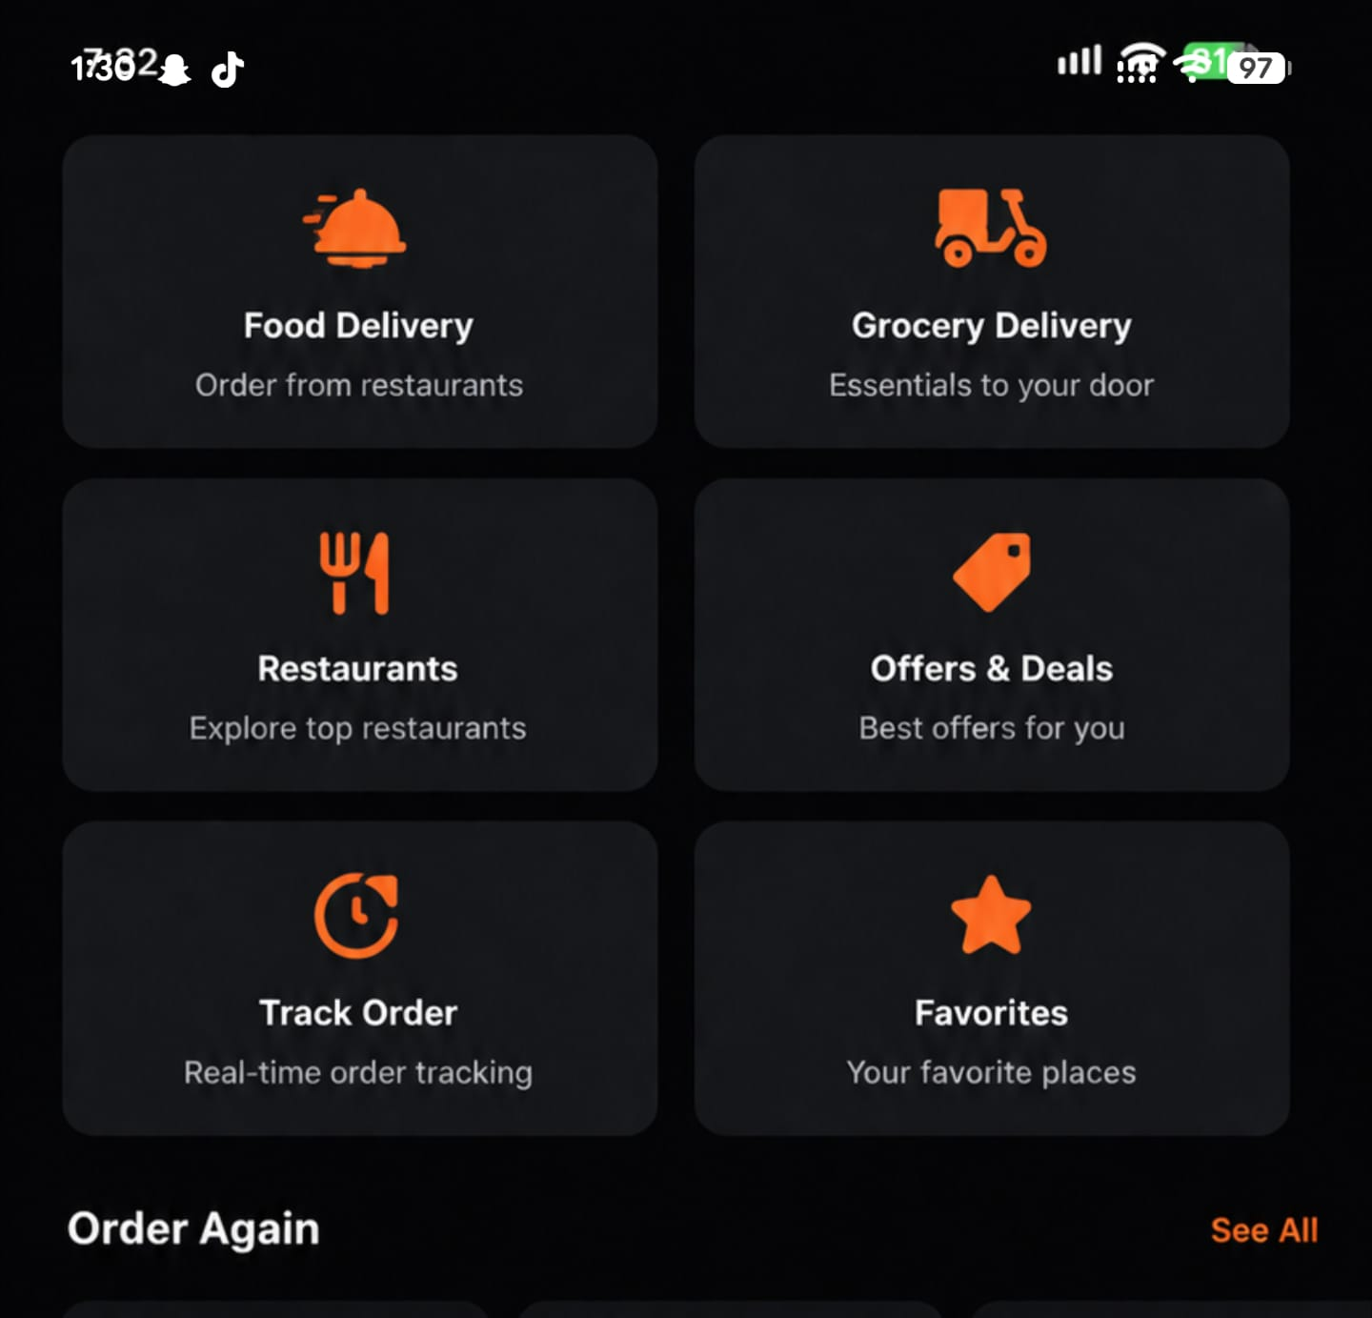
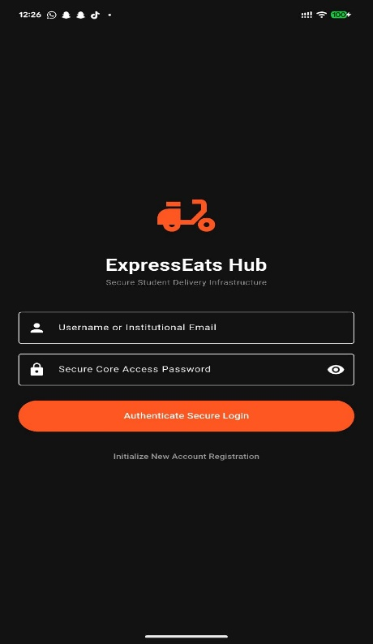
Food Delivery App – User Guide Manual
Welcome
Thank you for choosing our Food Delivery App, designed to bring your favorite meals straight to your doorstep. The app allows you to browse local restaurants, customize your orders, track deliveries in real time, and receive personalized food recommendations based on your preferences.
System Requirements
Platform: Android smartphone (Android 8.0 or later)
Connectivity: Active internet connection (Wi-Fi or Mobile Data required for ordering and tracking)
Getting Started
1. Install and Open: Download and open the Food Delivery app.
2. Create an Account: Tap, Register to set up a new profile.
3. Enter Details: Input your full name, email, phone number, and a secure password.
4. Log In: Access the app anytime using your registered email/username and password.
Using the App
Dashboard (Home Screen):Browse top-rated restaurants, current promotions, popular cuisines, and your recent orders.
Menu & Customization: Explore detailed menus, filter by dietary preferences, and customize individual dishes (e.g., add toppings, select spice levels) before adding them to your cart.
Smart Recommendations: Receive personalized meal and restaurant suggestions curated to match your taste profile and ordering history.
Order Placement & Checkout: Review your shopping cart, select or input your delivery address, apply promo codes, and securely check out.
Real-Time Tracker: Monitor your order status instantly, from restaurant kitchen preparation to the live GPS location of your delivery driver.
Order History: View your previous orders to quickly re-order your favorite meals with a single tap.
Profile Management: Update your delivery addresses, contact information, and payment methods whenever needed.
Troubleshooting
Unable to log in: Verify your username/email and password details.
App not responding: Force-close and restart the application, or reboot your device.
Order status not updating: Ensure you have a stable internet connection. If the issue persists, refresh the tracking page.
Support
For immediate assistance with an ongoing order or account issues, contact our support team through the in-app chat or email us at: support@fooddeliveryexpresseats.com

Thank you for ordering with us. Enjoy your meal!
Product Pitch
Our application is a seamless Food Delivery App engineered to connect users with a diverse culinary marketplace right from their smartphones. Built with simplicity and speed in mind, the platform allows users to securely register, browse dynamic restaurant menus, customize orders, and track their deliveries in real time via live GPS. Additionally, the app features an intelligent recommendation engine that suggests new dishes based on individual user tastes.
It is intuitive, user-friendly, and perfect for busy individuals, families, and food enthusiasts alike. In future iterations, we plan to roll out eco-friendly delivery routing, AI-powered group ordering splits, and a loyalty rewards program to keep our community engaged and well-fed.

